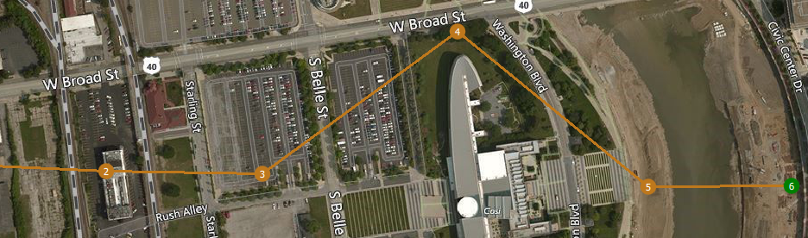

Obstacle

Waypoint Path

UAV Path